**Task Sheet:** The Black Muslim Experience

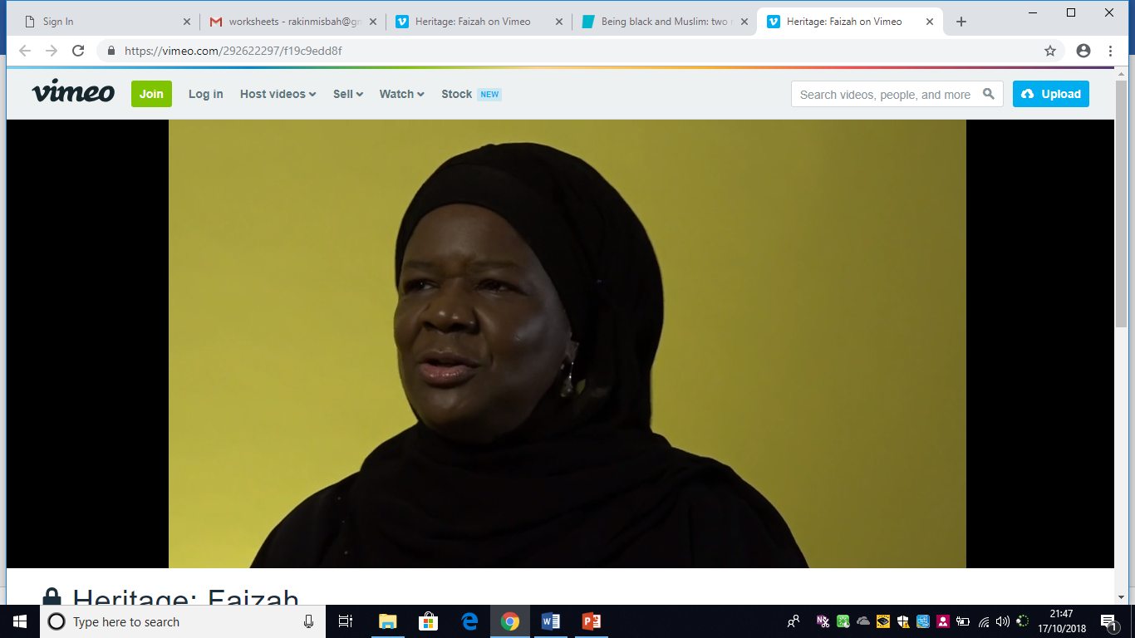

# [Click here to watch: Faizah Salihu](https://youtu.be/6dxBKHwaPTM)

1. Faizah reflects on things that make her British. What are they?

____________________________________________________________________________________________________________________________________________________________________________________________________________________________________________________________________________________________________________________________

2. Why was her experience traumatising?

_____________________________________________________________________________________________________________________________________________________________________________________________________________________________________________

3. How did Faizah learn about her African heritage?

_____________________________________________________________________________________________________________________________________________________________________________________________________________________________________________

4. How did Faizah find her way to Islam?

_____________________________________________________________________________________________________________________________________________________________________________________________________________________________________________

5. Do you think Faizah enjoyed her experience living in London? Explain why? ______________________________________________________________________________________________________________________________________________________________

_______________________________________________________________________________