Cut-up and match these famous British Muslims with their names and occupations.

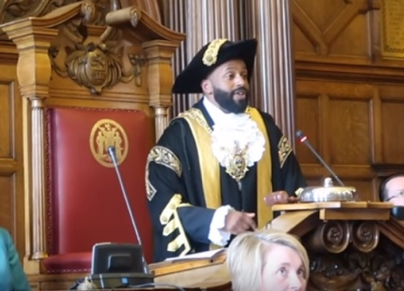
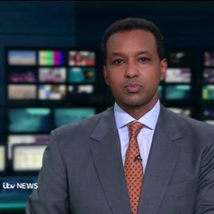

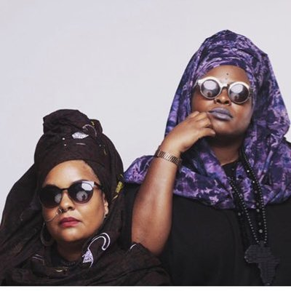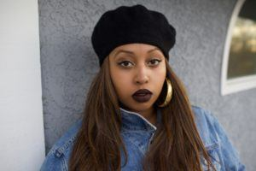

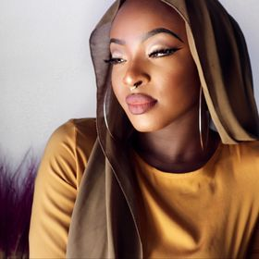

Warshan Shire

Zainab Hassan

Poetic Pilgrimage

Rageh Omer

Magid Magid

Athlete

Mayor of Sheffield

Poet

Hip hop rapper

Instagram Make-up Artist

Answers
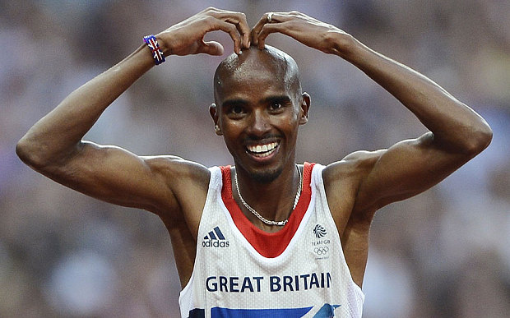 Mo Farah Athlete
Rageh Omar Newsreader / jounalist
Poetic Pilgrimage Hip-hop / rappers
Warsan Shire Poet
Zainab Hassan Instagram Make-up artist
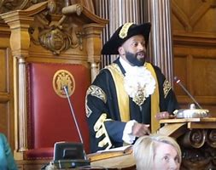 Magid Magid Mayor of Sheffield
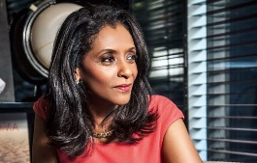 Zeinab Badawi Jounalist

