Source Sheet: Saadat Yusuf
Excerpt from an oral history interview conducted with Saadat Yusuf female born 1943 who arrived in England in 1965

Source 3f
Interactions With The Locals
“I make friends with my next door neighbour opposite. She’s a Irish lady but her husband is Nigerian, yeah so she’s the one who actually take me on. And I still I mean she passed away now, but her children I still see one or two of them. Yes, she’s the best lady I ever met.
She’s the one that helped me to go round and go to the shops and you know go and learn English more. Because we speak English in Nigeria but it’s not the same when you come here, it not the same.
She introduced me to GP, and so on. She’s a very nice lady, very nice lady.”

Source 3g
Saadat’s Experience With Discrimination
“… The only thing I notice is the shops some of the shops they don’t want black people to go in there and so on and you see on the notice board you know people put a notice to rent a room and then there goes ‘no black, no Irish, no dog’. You know I seen that with my own eyes. But otherwise nothing directly at me as an individual.”

SOURCE 4a
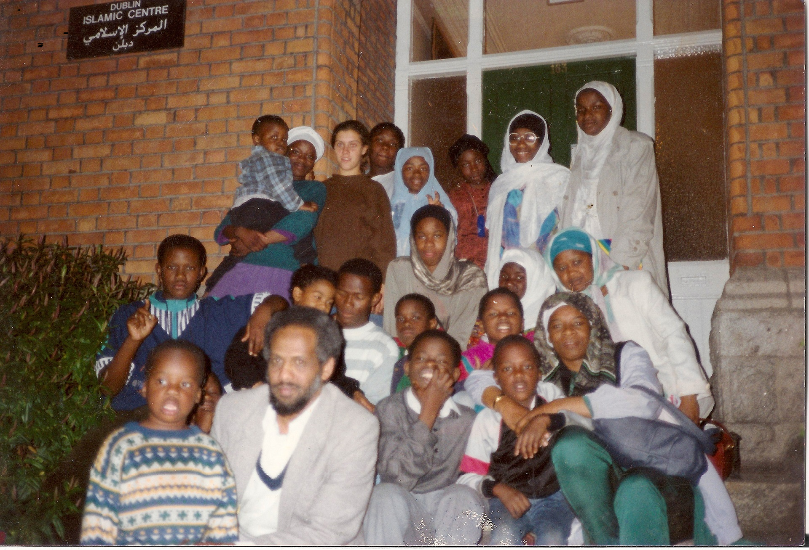
A photograph taken by The Muslim Sister’s Jamaat whilst on a trip to Dublin. Saadat Yusuf is on the second row on the far right with a blue scarf.
SOURCE 4b
THE NEED FOR COMMUNITY
Excerpt of an oral history interview conducted with female Saadat Yusuf born 1943 who arrived in England in 1965.
“Because as you say the Muslim women has no other places to go and to meet other people we started this Muslim Sister’s Jamaat I think it’s in 1986 or ’85. I wasn’t around with them at the time but it was a few sisters who actually embraced Islam at that time they wasn’t a Muslim, they embraced Islam they the ones started Muslim Sister’s Jamaat. And one of them invite me because her husband is a friend of my husband she invited me to be with them and so I been with them since. But for the last twenty years I actually run it and I’m the coordinator, you know of the organisation.”
SOURCE 4c
Excerpt of an oral history interview conducted with female Saadat Yusuf born 1943 who arrived in England in 1965.
“The role is actually to create a space for sisters. You know that its sisters only with young children they can come. The first time we used we started sister’s house like in here and we had teas and coffee and whatever. And the women just chat and so on. And then we improve in Ramadan we do like the last ten days in different sisters house. We actually sleep in sister’s house. And in here, you know, we sometimes do the last three days here and so on. So and we improved that we do classes.
SOURCE 4d
“Yeah, it’s a support group.
Yes that’s why we say Muslim sisters, it’s not Nigerian, or African or Asian or whatever…sisters. Whatever you come from as long as you’re Muslim. However, even now we have the non-Muslim come. Why? Because some of the sisters they embrace Islam and they have their cousins or whatever are not Muslim so they say “Oh come you know to the group” and they come.“

