Source Sheet: Black Muslims In Britain

Source 3b

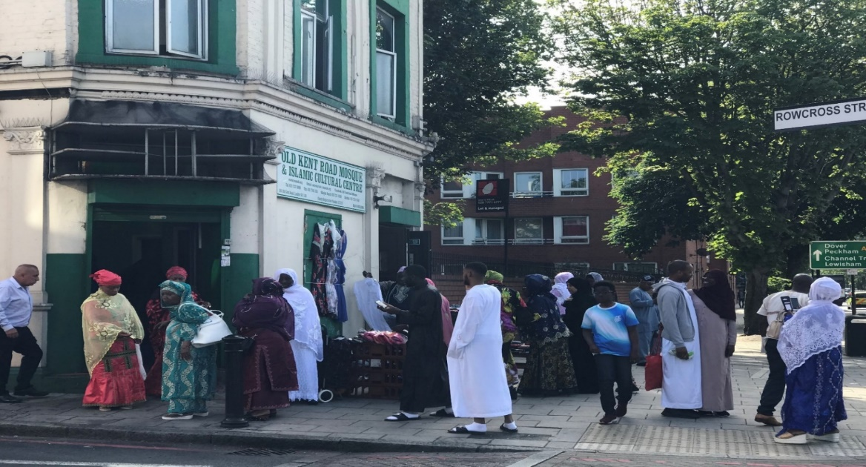

This Photograph is of The Muslim Association of Nigeria (MAN) on Old Kent Road. It is one of the first black owned mosques in the UK and is found in South London. It is also known as the Old Kent Road Mosque.

