The pioneers of Islam in Woking
Brief bios of the key figures in the development of Islam in Woking

Sultan Shah Jahan, Begum of Bhopal  (1838-1901)  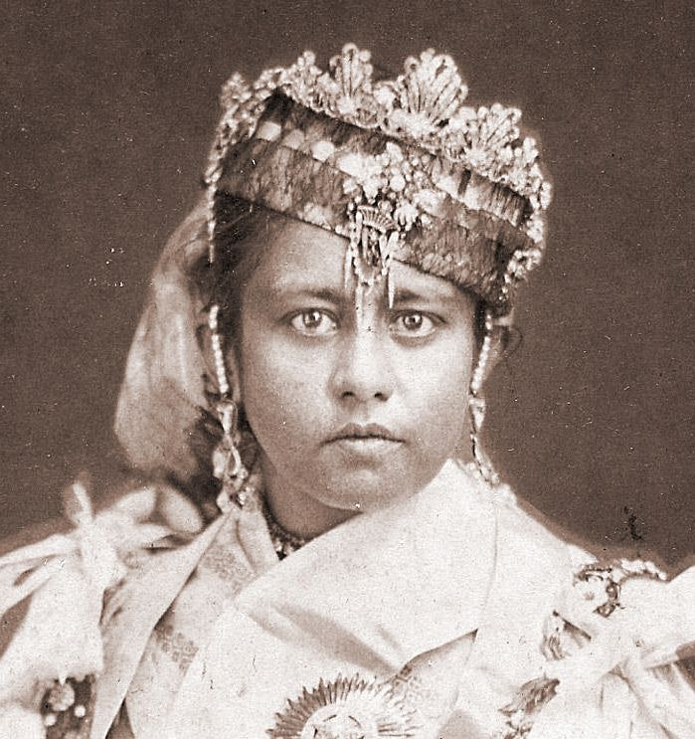 | One of the only female Indian rulers in history. The Begum ruled over the area of Bhopal in central India from 1844-60 (as a six-year-old) and again from 1868-1901. She is believed to have authored several books in Urdu. | Gottlieb Wilhelm Leitner  (1840-1899)  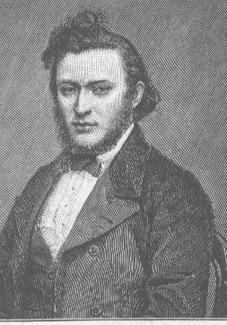 | A scholar and linguist of Jewish heritage who was born in Pest, Hungary and grew up in Istanbul, Turkey. He also taught at King’s College, London and helped found the University of Punjab in India.
Khwaja Kamal-ud-Din  (1870-1932)  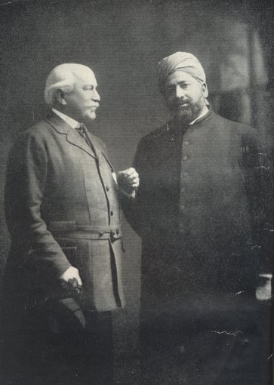 | Khwaja Kamal ud-Din was born in Punjab, India and trained as a lawyer. He was also a prominent missionary of the Ahmadiyya movement and published several books on Islam and other faiths as well as commentaries of the Qur’an. | Rowland George Allanson Allanson-Winn, 5th Baron Headley, aka Lord Headley  (1855-1935) | An Irish peer who was born in London and Cambridge University who went on to become a civil engineer. An enthusiastic boxer, he converted to Islam in 1913.

